

INFORMATION TECHNOLOGY PROGRAMME

COMP902 Advanced Information Technology Specialised Project
Progress Report

Student Name | Viacheslav Vorozhbit
Student ID | 20230119
Project Title
Supervisor | Dr. Saranya Selvarangan
Report# | 2
Date | 23 July 2026

Contents

Progress 3
Completed Tasks 4
AI-Builder Action 4
Creating an AI assistant Claude Cowork 5
Using Notion 7
Problems Encountered 8
Key Findings 8
Plan for Next Period 9
References 10

Progress
At this stage of my research project, I conducted an in-depth study of AI-based tools that could be used in the construction manager's workplace.
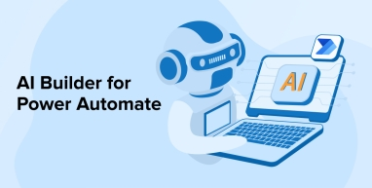
In conjunction with Power Automate the AI Builder tool can be successfully used. This tool can perform many functions and is especially useful at the stage when it is necessary to read letters, recognize the text, draw a conclusion and present this conclusion to the manager in a short and concise form. Because there can be a lot of email and notifications, and a manager needs to perform many tasks during a busy work day, it is very important that the conclusion is short and concise. This AI tool can be self-learning and adapt to a specific manager's behavioral patterns, even generating responses and offering them for selection. With the manager's participation, the AI Builder will self-learn and offer a more focused and precise response.
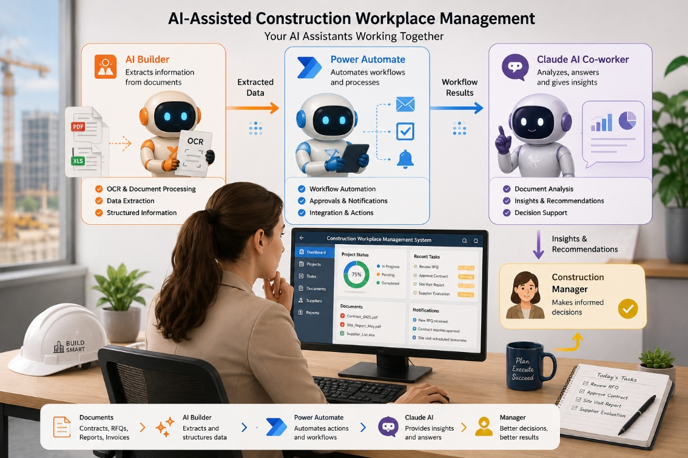
This AI-generated picture
AI Builder is very useful for text recognition, and although it's paid for in the Enterprise configuration, its free trial version also has many features. This is very important, as correspondence always arrives in a heterogeneous format.
Users, such as construction companies, prefer to store some data locally, but they also distribute other data to the cloud for shared access and increased reliability. Therefore, the ability of Power Automate to combine processes for local and cloud storage was explored.
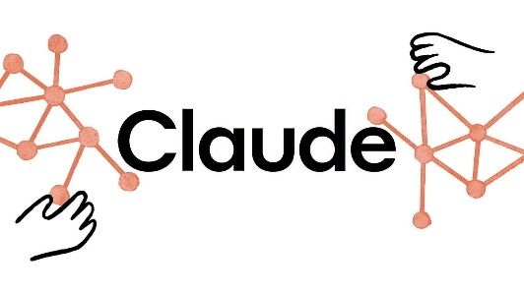
Also in this period I conducted an assessment of the use of another fashionable Cloud AI tool.
This modern tool has a wide range of capabilities for automating routine processes in a very easy way, allows you to create AI mini-assistants to automate routine work and is a cutting-edge technology.
Despite the fact that AI Claude is very versatile, it cannot completely replace Power Automate, and in combination they can be very effective and useful.

Completed Tasks

AI-Builder Action
Connecting AI Builder to a Power Automate workflow occurs after extracting an attachment from an email, depending on whether the attachment is a PDF or an image, the content is extracted as a byte array. Next, the AI Builder action is added - Recognize Text in Image - and place the response into a predefined structure.
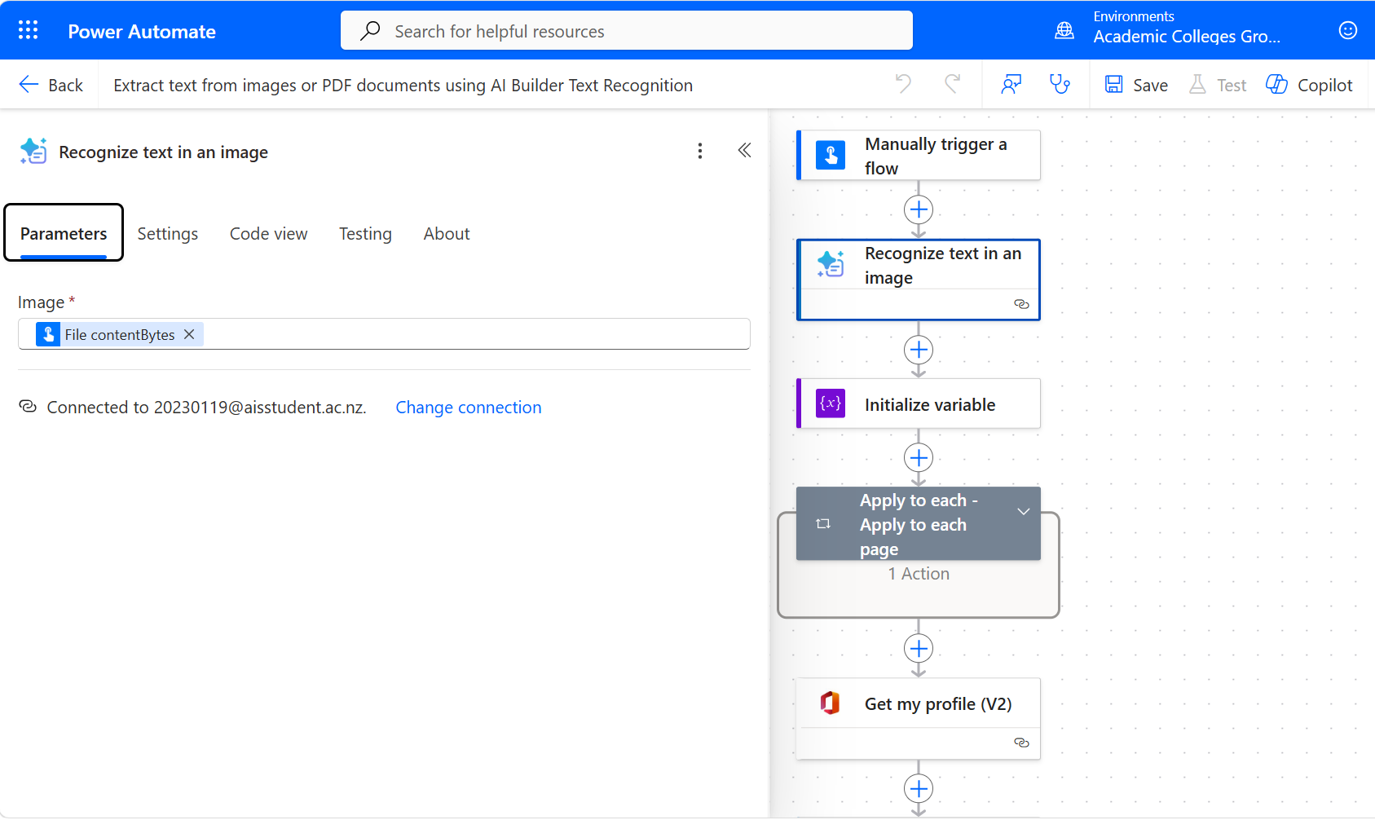

The data can then be processed by another action or sent to the next process, such as entering it into a Project cost summary.

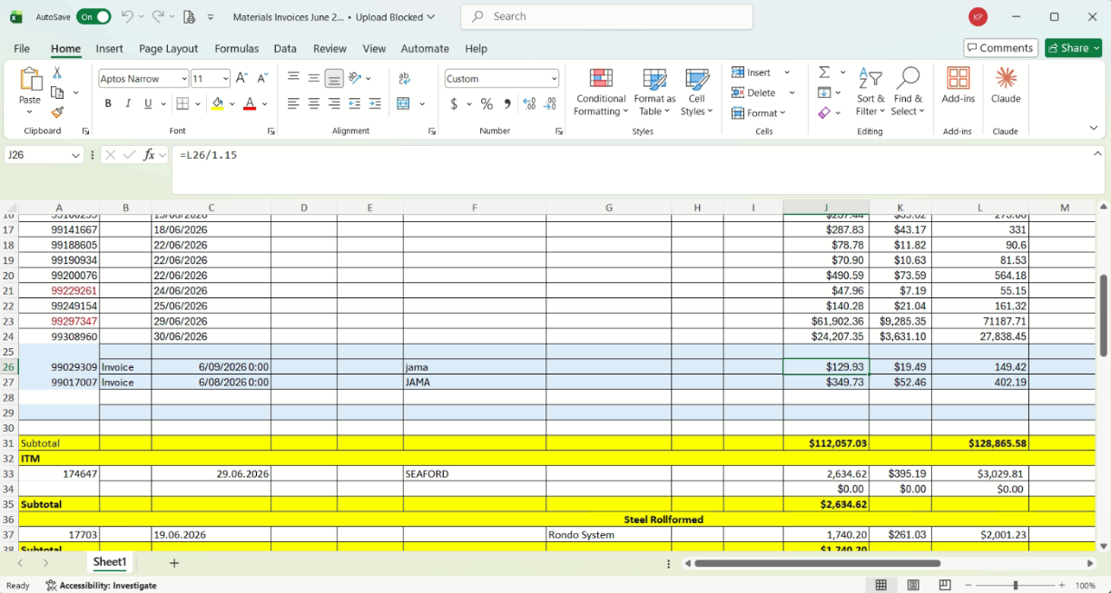

Creating an AI assistant Claude Cowork
The Claude Cowork system offers a very convenient mechanism for configuring interactions between various system components. For example, to set up an assistant to create your schedule for tomorrow or next week, simply connect to the Google Calendar connector and log in.
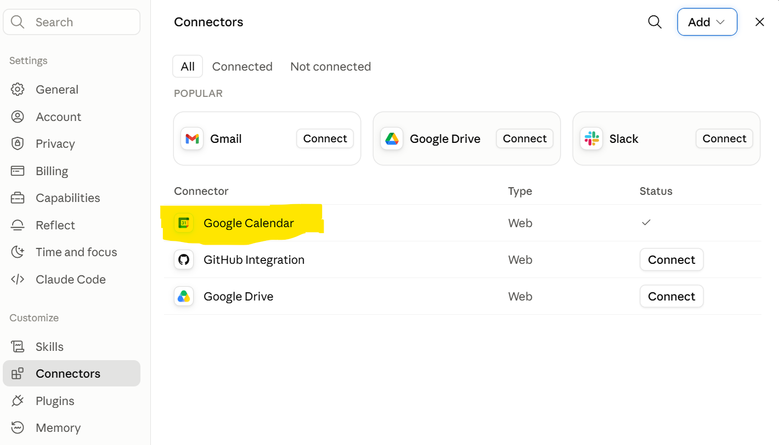
You can write a message to the Claude that it should put information about meeting to the schedule in specific day and time. The Claude will create a meeting and automatically uploade it to the Google Calendar. The same way you can cancel also any meetings regular or one-time just simply write text - cancel my meetings on Thursday at 3:00 PM
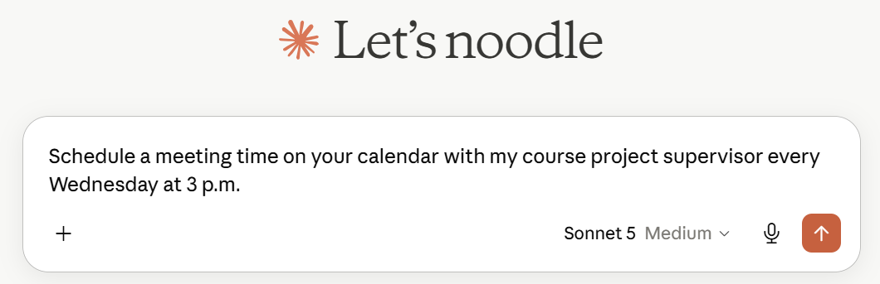
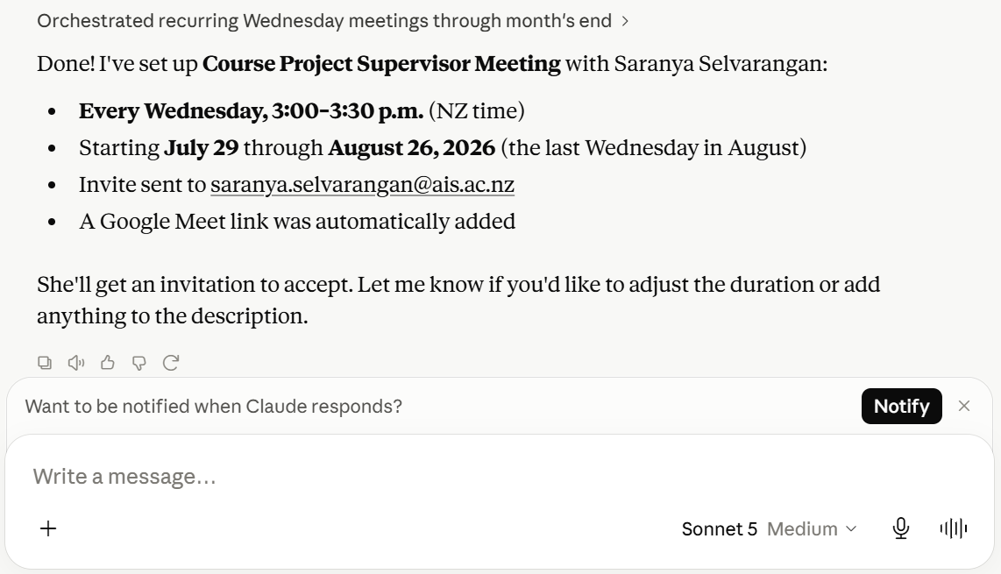
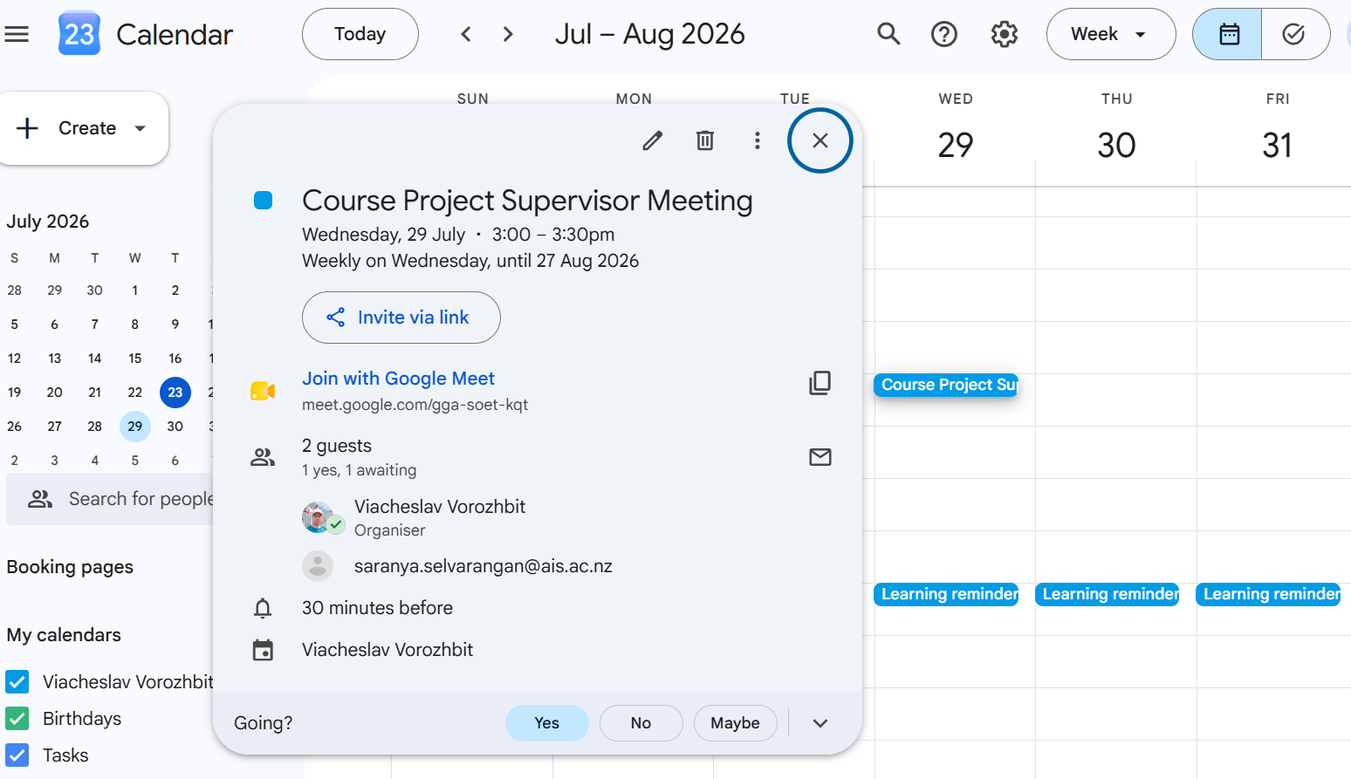

Using Notion
Notion, as a universal database, is a very popular and flexible tool used as an organizer, allowing you to create notes, monitor tasks, and create to-do lists. When properly configured and used, Notion can replace numerous disparate programs and be used centrally by teams of developers and managers.
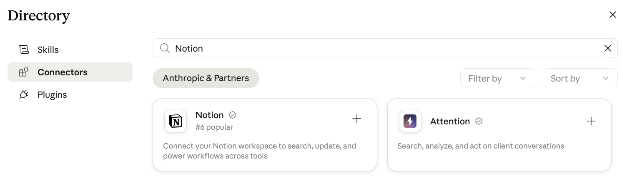
After that, just write to Claude, Go to Notion, open the DownTown Project, calculate the amounts and deadlines, and make me a plan for distributing tasks to contractors for next week.
Next step, Claude will prepare all the necessary documents and, if necessary, prepare a letter to the contractors using a pre-agreed format. For example, if it's a request for an estimate from electrical contractors, Claude will generate a letter based on the data and Notion database for a specific project, create a list of relevant contractors, attach supporting documents, and wait for approval. After approval, he can send the letters directly from Claude; the Outlook connector must be enabled for this.
At the same time, the cloud is a structured self-learning tool where you can create separate projects for work, study, or conferences, and add your skills or take skills from existing public libraries.
A big advantage of Claude is that it can use any connectors of popular publicly available applications from both Google and Microsoft, and you can also create your own proofreaders, which makes it even more flexible.
It is worth noting that Claude in the free version is already a very fashionable multifunctional tool, but for small businesses, the paid version can be used, which has an even more powerful mechanism.

Problems Encountered
I encountered a problem with Microsoft Copilot, which can't generate workflows automatically. When I type in natural language, it only provides recommendations and a rough process structure. Sometimes there are discrepancies with the options Copilot suggests. Perhaps it doesn't take into account the versions of Power Automate I'm using.
The practice shows that AI Builder doesn't always accurately recognize scanned documents. I see in most cases It depends on the resolution and image quality, but AI can learn this. However, sometimes subcontractors or suppliers may send handwritten documents and AI Builder recognizes them with up to 80% accuracy, and in this case it requires employee involvement. For such cases the system must provide and signal the manager about the need for intervention.

Key Findings
At this stage of my research, I discovered that there are many AI technologies, and they complement each other. AI tools like ChatGPT are quite capable of performing a full range of tasks and learning as they go, but some are best suited for specific tasks.
For example, Claude as a colleague is more convenient in settings for routine tasks not because he is smarter, but because he has special tools for this.
Low-code programming tools also significantly improve workflow programming and, with some training, make them easy to use and allow the specialist to focus on the logic of the business process rather than development.
For example, I learned that Power Automate can automatically initiate a process when an event occurs, such as an email in Outlook, a message in Telegram, or a database entry, while Claude AI waits for user commands. Claude AI can process messages and generate response options, but it won't send them automatically. Therefore, the combination of Power Automate, AI Builder, and Claude AI helps create a more robust workflow management tool both locally and in the cloud.

Plan for Next Period
In the next period in my research, I intend to dive deeper into the differences of AI tools in using in managment of contruction. I am plaing to conduct research and explore alternative options and apply the thecn on practic. And I also want to identify current gaps in this technology. I'm also beginning to develop the Final report for my Research project.

References
Darrel Wilson. (2026, April 10). Claude Tutorial for beginners — How to use Claude AI step by step (2026) [Video]. YouTube. https://www.youtube.com/watch?v=-xEF5WrdIWs
Habib, H. (2024). OpenAI API Cookbook: Build intelligent applications including chatbots, virtual assistants, and content generators. Packt Publishing Ltd.
Kevin Stratvert. (2026, April 30). Claude AI Tutorial for Beginners (Step-by-Step) [Video]. YouTube. https://www.youtube.com/watch?v=r2vYObllqJU
Kevin Stratvert. (2021, November 17). Microsoft AI Builder Tutorial - Extract Data from PDF [Video]. YouTube. https://www.youtube.com/watch?v=J3d6bx3i4l0
Koduri, N. K., & Piridi, S. Low-Code AI-Driven Patient Intake System Using Microsoft Power Platform and AI Builder.
Pothireddy, S. R. (2025). AI-Powered Copilots Are Revolutionizing Low-Code Development in the Power Platform. International Journal of Communication Networks and Information Security, 17(2), 86-115
Stratton, J. (2024). Copilot for Microsoft 365: Harness the power of generative AI in the Microsoft apps you use every day. Apress.

